Genomic DNA Sample QC
Version Number: 5.1
Version Date: 6/29/2020
Authors:
Mansi Chovatia, Aditi Sharma, Juying Yan, Kathleen Lail, Timothy Williams, Alba Guiterrez, Chia-Lin Wei and Yuko Yoshinaga

SUMMARY
Before shipping your genomic DNA samples, please be sure to follow the JGI sample preparation and sample submission guidelines available at https://jgi.doe.gov/user-program-info/pmo-overview/project-materials-submission-overview/
This protocol describes how to perform quality control of DNA samples to evaluate the quantity (using Qubit Fluorometer), quality (using standard agarose gel electrophoresis or electropherogram) and purity (using NanoDrop Spectrophotometer). We recommend all DNA samples to be evaluated with this protocol prior to shipping to JGI.

MATERIALS

Materials | Vendor | Part Number
Disposables
Pipette tips
1.5 mL microcentrifuge tubes
Qubit assay tubes (0.5 mL) | ThermoFisher | Q32856
Reagents
Qubit dsDNA BR Assay Kit | ThermoFisher | Q32853
Qubit dsDNA HS Assay Kit | ThermoFisher | Q32854
QuantiFluor™ dsDNA System Kit | Promega | E2670
High Sensitivity Large Fragment 50 kb Analysis Kit | Agilent (AATI) | DNF-464
GenePure LE Agarose | ISC BioExpress | E-3120-500
50x TAE Buffer | GrowCells | MRGF-4210
SYBR™ Safe DNA Gel Stain | ThermoFisher | S33102
DNA Molecular Weight Marker II (0.12-23.1 kb: lambda DNA - HindIII) | Roche | 10 236 250 001
Gel Loading Dye, Blue (6x) | New England Biolabs | B7021S
Lambda DNA | ThermoFisher | SD0011
1X Low EDTA-TE Buffer, pH 8.0 | VWR | 10128-588
Equipment
Pipettes
Microcentrifuge
Vortex
Qubit Fluorometer | ThermoFisher | Q32871, Q33216, Q33226
Fragment Analyzer Automated CE System | Agilent (AATI) | FSv2-CE2F
Molecular Imager Gel Doc XR System w/Image Lab™ Software | Bio-Rad | 170-8170
12x14cm Horizontal Gel Electrophoresis Device | CLP | 72.1214
12x14cm Horizontal Device Comb (25 well, 1.5mm) | CLP | 72.1214-MT-25D
NanoDrop Spectrophotometer | ThermoFisher | ND-1000, ND-2000, ND-3300, ND-ONE-W

SAFETY INFORMATION
  - Safety glasses, lab coat, and nitrile gloves should be worn at all times while performing work in the lab during this protocol.

PROCEDURE
- Preparation
  - Extracted gnomic DNA samples could be stored at -80°C until ready to begin lab work
  - Thaw DNA samples on ice
  - Gently mix samples by tapping the tubes (avoid vortex) and quick spin before opening the tubes
  - Wide-orifice pipette tips are preferable to pipette high molecular weight DNA
  - Record the volumes measured by pipette
- Quantification by Qubit Fluorometer
Note: If a microplate reader is available, Promega QuantiFluor™ dsDNA System kit is recommended for DNA quantitation with a large number of samples. A four point standard curve including a blank could be used for the assay which is utilized in JGI quantification system (0, 2, 10, 200 ng/μL standard points for a broad range assay and 0, 0.4, 2, 20 ng/μL for a high sensitivity assay).
Note: NanoDrop measurements are generally not reliable as quantification and JGI does not accept the concentration measured by NanoDrop.
  - Set up the number of 0.5 mL Qubit assay tubes you will need for 2 standards and samples
  - Label the tube lids
  - Make the Qubit working solution by diluting Qubit dsDNA BR reagent 1:200 in Qubit dsDNA BR buffer in microcentrifuge tubes (each assay tube requires ~200 μL of working solution)
  - Load 190 μL of Qubit working solution and add 10 μL of each Qubit standard, vortex 2-3 seconds and quick spin (200 μL final volume)
  - Load 198 μL of Qubit working solution and add 2 μl of your sample, vortex 2-3 seconds and quick spin (200 μL final volume)
  - Incubate at room temperature for 2 min
  - On the Qubit Fluorometer, select your assay (dsDNA Broad Range), press YES to run a new calibration, and then insert the tube containing Standard #1. Close the lid, and press READ
  - Insert the tube containing Standard #2, close the lid, and press READ. Calibration of Qubit is now complete
  - Insert the tube containing DNA sample, close the lid, and press READ
  - Select calculate concentration, select the volume (2 µL), select the measurement units as ng/µL, and record your concentration. Repeat for all DNA samples
    - If the sample concentration is too low, then use dsDNA HS Assay kit
    - If the sample concentration is too high, then set up serial dilutions of your samples and repeat the assay using dsDNA BR Assay kit
Note: We recommend using 2 µL of each sample instead of 1 µL to increase the accuracy
Note: We recommend using 2 µL of Standard #2 to be treated as a sample to verify the Qubit was calibrated correctly. If the concentration of this standard is above ±10% of the expected concentration, then please recalibrate the Qubit.
Note: Review JGI Sample requirements and concentrate samples if they are too dilute. Speedvac without applying heat is recommended for concentrating samples to minimize degradation and yield loss
- Quality check
Note: Degraded DNA is especially affective to create successful large insert libraries above 10 kb insert. It is recommended to reextract genomic DNA if any degradation is observed with samples for long insert library types.
Note: Pulse-field gel electrophoresis and Sage Pippin Pulse are alternatives of standard gel or electropherogram methods described here. Check manufacturer’s guidance to use those apparatuses.
  - Fragment Analyzer
Fragment Analyzer with high sensitivity large fragment 50 kb kit could provide an accurate size measurement of genomic DNA with low amount (1-2 ng) of gDNA (50 pg/μL to 5 ng/μL input DNA with optimal concentration at 1 ng/μL). While 0.7% agarose gel sizing range is 2 - 20 kb, Fragment Analyzer with HS 50kb kit sizing is range 75 bp - 48,500 bp. Fragment Analyzer has smear analysis function and provides GQN (Genomic Quality Number) to help the assessment of genomic DNA quality. Please follow the manufacturer guide to operate the equipment.
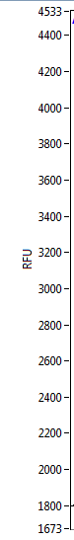
UM
LM
GQN 5.0 3.3 8.3
Y
M
N
Figure 2. Electropherogram and gel-like image of genomic DNA loaded on Fragment Analyzer with HS 50 kb kit. 3 samples with various qualities were loaded with red as Y (Yes): intact high molecular weight DNA, blank as M (Marginal): gDNA with slight degradation and blue as N (No): severely degraded DNA. GQNs (genomic DNA quality number) are indicated under the gel-like image. LM: lower marker at 1 bp, UM: upper marker at 200 kb.
  - Agarose gel
Recommended: prepare serial dilutions of lambda DNA to cover the range of 1 to 25 ng/µL in 1x TAE buffer with 1x loading dye in advance. Loading 5 μl of each will provides 5 to 125 ng of mass standards on the gel which will give a rough but accurate estimate of DNA concentration. The mass standard also serves as a reference of intact genomic DNA.
    - Prepare ~100 mL of 0.7% agarose gel with 1x TAE buffer and 10 µL of SYBR Safe DNA gel stain
    - Based on the concentrations measured in step 2, transfer approximately 30-60 ng of genomic DNA per sample into a new microcentrifuge tube and bring the volume to 5 µL with 1x TE buffer
    - If the concentration is higher than 100 ng/µL, dilute the sample to 30 ng/µL and transfer 2 µL
    - Add 1 µL of 6x loading dye
    - Mix well and quick spin
    - Load 6 µL of each sample and 5 µl of Marker II.
    - Optional: Load 5 µL of each of the lambda DNA mass standards
    - Run the gel for 90 min at 90 V in 1x TAE buffer
Note: Run time and voltage are different per used electrophoresis equipment: ensure the genomic DNA bands have ran more than 2 cm below from the well and the separation of the bands in the ladder is apparent.
    - Image the gel and store the image
    - Analyze the gel image based on following criteria:
    - High molecular weight genomic DNA should appear to be a tight band at ~23 kb
    - Any sign of smearing below 23 kb is considered as degraded DNA
    - Any sample remained in the well of the gel could mean that DNA did not dissolve in the solution completely or presence of other contaminants
1 2 3 4 5 6 7 8 9 10 11 12 13 14 15 16 17 18 19 20
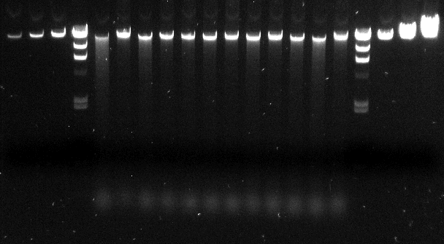
N Y N M M M Y M Y M N Y
4.3 kb
6.6 kb
9.4 kb
2.0 kb
2.3 kb
23.1 kb
Figure 1. An example of genomic DNA loaded on 0.7% agarose gel with 1x TAE buffer and SYBR Safe run at 90 V for 90 min. Lanes1, 2, 3, 18, 19 & 20: lambda DNA mass standards with 8, 16, 31, 62.5, 125 & 250 ng; lanes 4 & 17: Marker II (Roche) lambda-HindIII marker; lanes 5 – 16: gDNA sample loaded with 50 ng/lane. gDNA quality calls were indicated on the gel image as Y (Yes): intact high molecular weight DNA; M (Marginal): gDNA with slight degradation; N (No): severely degraded DNA.
- Purity check by NanoDrop
Note: JGI uses NanoDrop to determine sample purity only. We do not recommend using NanoDrop to determine sample concentration. We recommend submitting high purity DNA samples with appropriate OD measurements. Data from Nanodrop helps in troubleshooting whether the contaminants present in the sample. Low purify samples are recommended to re-purified with suitable purification methods.
  - Clean pedestal and sampling arm with nuclease-free water and a KimWipe
  - Pipette 1.6 µL of nuclease-free water directly onto the pedestal and lower the sampling arm
  - Surface tension is used to hold samples between two optical fibers
  - Select “Initialize” from the NanoDrop software
  - When the initialization is complete, raise the sampling arm and wipe the pedestal and the arm with a KimWipe
  - Select “Nucleic Acid” and the appropriate “Sample Type”
  - Pipette 1.6 µL of 1X Low EDTA-TE Buffer, used in the DNA sample, directly onto the pedestal
  - Lower the sampling arm and select “Blank”
  - When the measurement is complete, raise the sampling arm and wipe the pedestal and the arm with a KimWipe
  - Pipette 1.6 µL of DNA sample onto the pedestal and lower the sampling arm
  - Select “Measure”
  - When the measurement is complete, record A260/A280 and A260/A230 ratios
  - Between and after all sample measurements, clean the pedestal and arm with nuclease-free water and a KimWipe
  - Review the spectral image and the absorbance ratios to assess the purity of the sample using the following guidelines (refer Figure 3):
• The wavelength of maximum absorption for both DNA and RNA is 260nm, while the maximum absorbance for proteins is at 280 nm.
• A260/A280 ratio of ~1.8 is generally accepted pure DNA samples. A low 260/280 ratio may be the result of a contaminant such as protein or a chemical that is absorbing at 280 nm.
• A260/A230 ratio of 1.8-2.2 is generally accepted pure for nucleic acid. A low A260/A230 ratio may be the result of contaminant absorbing at 230 nm. Such contaminants include carbohydrates, residual phenol, residual guanidine and glycogen. On the other hand, a high A260/A230 ratio may be the result of either making a blank measurement on a dirty pedestal or using a blank solution that is not of a similar ionic strength as the sample solution.
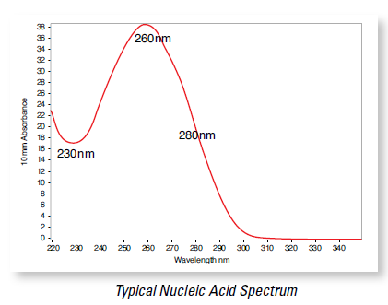
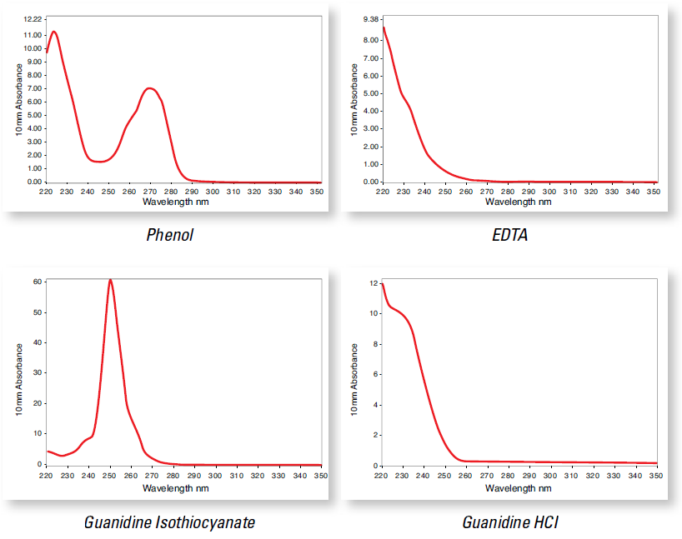

Figure 3. Examples of NanoDrop spectrophotography with high-purity genomic DNA (left) and various possible contaminants (right).

APPENDIX: REFERENCES
- Qubit:
- Qubit dsDNA BR Assay: https://assets.thermofisher.com/TFS-Assets/LSG/manuals/Qubit_dsDNA_BR_Assay_UG.pdf
- Qubit dsDNA HS Assay: https://assets.thermofisher.com/TFS-Assets/BID/manuals/MAN0017455_Qubit_1X_dsDNA_HS_Assay_Kit_UG.pdf
- Quantifluor dsDNA System:
https://www.promega.com/-/media/files/resources/protocols/technical-manuals/101/quantifluor-dsdna-system-protocol.pdf

- Fragment Analyzer:
  - High Sensitivity Large Fragment 50Kb Analysis: https://www.aati-us.com/documents/quick-start-guides/dnf-464/dnf-464-quick-start-guide-96-capillary-11-03-2015.pdf

- Image Lab™ Software:
http://www.bio-rad.com/en-us/product/image-lab-software?source_wt=imagelabsoftware_surl

- NanoDrop :
- T042 Technical Bulletin – NanoDrop 260/280 and 260/230 Ratios:
http://www.nhm.ac.uk/content/dam/nhmwww/our-science/dpts-facilities-staff/Coreresearchlabs/nanodrop.pdf
- User manual for ND-1000:
https://www.baylor.edu/bsb/doc.php/210102.pdf

